INDUSTRY PROJECT REPORT
Online Event Booking and Management System
Industry Project Title | Online Event Booking and Management System
Name of the Institute | Jayaprakash Narayan College of Engineering, Mahabubnagar, Telangana
Name of the Company | TCS
Start Date | 27-06-2026
End Date | 30-07-2026
Total Effort | 90 hrs.
Project Environment | Windows 11, Visual Studio Code, Node.js, React.js, Express.js, MongoDB
Tools Used | React.js, Node.js, Express.js, MongoDB, Mongoose, JWT, bcryptjs, Axios, Bootstrap 5, Git, GitHub, Postman, MongoDB Compass, Visual Studio Code
Submitted by: K. Vaishanavi
Final-year B.Tech , Computer Science Engineering

1. Acknowledgements
I would like to express my sincere gratitude to the Department of Computer Science and Engineering at Jayaprakash Narayan College of Engineering for providing me with the opportunity, guidance, and resources needed to design and build this Industry Project. I am thankful to my project guide and the faculty members who supported me throughout the various stages of development, from requirement analysis to final testing, with their valuable feedback and encouragement.
I also extend my appreciation to my peers and family for their continuous support and motivation during the course of this project. This project has been an invaluable learning experience that has strengthened my practical understanding of full-stack web development, database design, and secure application architecture.

2. Objective and Scope

2.1 Objectives
The primary objective of this project is to design and develop EventHub, a secure, full-stack, role-based online event booking and management platform that streamlines the process of discovering, creating, approving, and booking events. Specifically, the project aims to:
- Develop a centralized web application that supports three distinct user roles — Customer, Organizer, and Admin — each with a dedicated dashboard and permission set.
- Implement secure authentication and authorization using JSON Web Tokens (JWT) and bcrypt-based password hashing.
- Allow Organizers to create, edit, and manage events, with each submission routed through an administrative approval workflow before it becomes publicly visible.
- Enable Customers to browse, search, and filter approved events, and to book tickets with real-time seat availability tracking.
- Provide Administrators with a command-center dashboard for user management, event moderation, booking and refund oversight, and platform-wide analytics.
- Maintain an in-app notification system that keeps users informed of registrations, event approvals/rejections, and booking activity.
- Ensure all data is persisted reliably using MongoDB, with a well-structured schema for users, events, bookings, categories, and notifications.

2.2 Scope
The scope of this project covers the complete design and implementation of a responsive web application built on the MERN stack (MongoDB, Express.js, React.js, Node.js). It includes user registration and login, event lifecycle management (creation, approval, publishing, cancellation), a ticket booking engine with automatically generated booking references and QR codes, and administrative tools for platform governance and analytics. The current scope is limited to a web-based client; native mobile applications, real payment-gateway integration, and third-party notification services (email/SMS) are treated as enhancements for future iterations and are discussed in Section 15 (Enhancement Scope).

3. Problem Statement
Conventional event management practices — relying on spreadsheets, paper registers, phone calls, and disconnected communication channels — are slow, error-prone, and difficult to scale. Event organizers typically lack a centralized system to publish events, track ticket sales, and manage attendee lists, while attendees have no reliable way to verify event authenticity, check real-time seat availability, or retrieve a secure digital record of their booking. Furthermore, without a moderation layer, there is no mechanism to validate or approve events before they reach the public, creating opportunities for spam or fraudulent listings.
EventHub addresses these gaps by providing a single, secure, web-based platform where organizers submit events for administrative review, approved events are made instantly discoverable to customers, and every booking is recorded with a unique reference and QR-coded ticket. Role-based access control ensures that each type of user interacts only with the features relevant to them, while a centralized MongoDB datastore keeps all information — users, events, bookings, and notifications — consistent and auditable.

4. Existing Approaches
Before finalizing the design of EventHub, existing methods of handling event registration and ticketing were reviewed:
- Manual / spreadsheet-based management: Many small organizers still track registrations using spreadsheets or paper forms. This approach offers no automation, no real-time seat tracking, and is highly susceptible to human error and data loss.
- Generic third-party ticketing platforms (e.g., large-scale event-ticketing marketplaces): These platforms offer polished booking experiences but are built for high-volume public events, come with transaction fees, and do not provide a lightweight, customizable, self-hosted moderation workflow suited to smaller or institution-specific use cases.
- Ad-hoc web forms with email confirmation: Some organizers use form builders combined with manual email confirmations. This lacks role separation, does not enforce an approval workflow, and provides no verifiable ticket artifact (such as a QR code) for entry validation.
These existing approaches either lack the automation, security, and role-based control needed for reliable event administration, or they are too heavyweight, generic, and costly for a self-contained institutional or small-scale deployment. This motivated the development of a purpose-built, full-stack solution — EventHub — that combines an approval-driven event workflow with a modern, responsive user interface.

5. Approach / Methodology — Tools and Technologies Used
EventHub was developed using the MERN stack, a JavaScript-based technology set that allows a single language to be used consistently across both the client and server, simplifying development and integration.

5.1 Frontend
- React 19 (bootstrapped with Vite) — component-based UI library for building the single-page application.
- React Router DOM v7 — client-side routing between public pages and role-specific dashboards.
- Bootstrap 5 with Bootstrap Icons — responsive layout, grid system, and iconography.
- Axios — promise-based HTTP client for communicating with the REST API, configured with automatic JWT header injection.
- Chart.js with react-chartjs-2 — rendering of analytics charts (revenue growth, category distribution) on the Admin dashboard.
- lucide-react — icon set used across the interface.

5.2 Backend
- Node.js with Express.js — REST API server handling routing, business logic, and middleware.
- MongoDB with Mongoose ODM — NoSQL document database and schema modelling for Users, Events, Bookings, Categories, and Notifications.
- jsonwebtoken (JWT) — stateless authentication tokens issued on login and verified on protected routes.
- bcryptjs — one-way password hashing prior to persistence.
- express-validator — server-side request validation for registration, login, and password-reset endpoints.
- morgan and cors — HTTP request logging and cross-origin resource sharing configuration.
- dotenv — environment-based configuration management.

5.3 Development and Testing Tools
- Visual Studio Code — primary code editor.
- MongoDB Compass — GUI for inspecting and querying the MongoDB collections during development.
- Postman — manual testing of REST API endpoints.
- Git and GitHub — version control and source management.
- Nodemon — automatic backend server restarts during development.

5.4 Development Methodology
The project followed an iterative, module-by-module development approach. The backend data models and REST API were implemented first (authentication, events, bookings, admin, notifications), followed by integration of the corresponding React pages and dashboards for each role. Each module was manually tested end-to-end — through Postman for the API layer and through the browser for the UI layer — before moving to the next, allowing issues to be identified and resolved early.

6. Workflow
The overall functional workflow of EventHub is as follows:
- A new user registers as either a Customer or an Organizer, choosing the appropriate account type on the registration page.
- The system hashes the user's password with bcrypt and stores the account in the Users collection with the selected role.
- On login, the server verifies the credentials and issues a signed JWT containing the user's identity and role, which the client stores and attaches to subsequent API requests.
- An Organizer creates a new event by submitting details such as title, description, category, date, time, location, price, and seating capacity. The event is stored with an approvalStatus of "Pending".
- An Administrator reviews pending events through the Event Moderation panel and either approves or rejects each submission, optionally providing a rejection reason.
- Once approved, the event becomes visible on the public Explore Events page and is available for booking.
- A Customer browses or searches approved events, selects a ticket quantity, and confirms a booking. The server computes the total price, decrements available seats, and generates a unique booking reference along with a scannable QR code.
- The system automatically generates in-app notifications for key events — registration, event approval/rejection, and new bookings — which are delivered to the relevant user's notification dropdown.
- Customers can view their booking history and cancel an upcoming booking if needed; Administrators can view all system-wide bookings and simulate refunds through the Bookings & Refunds panel.
- Administrators additionally monitor overall platform health through the Analytics dashboard, which visualizes revenue growth and category distribution.
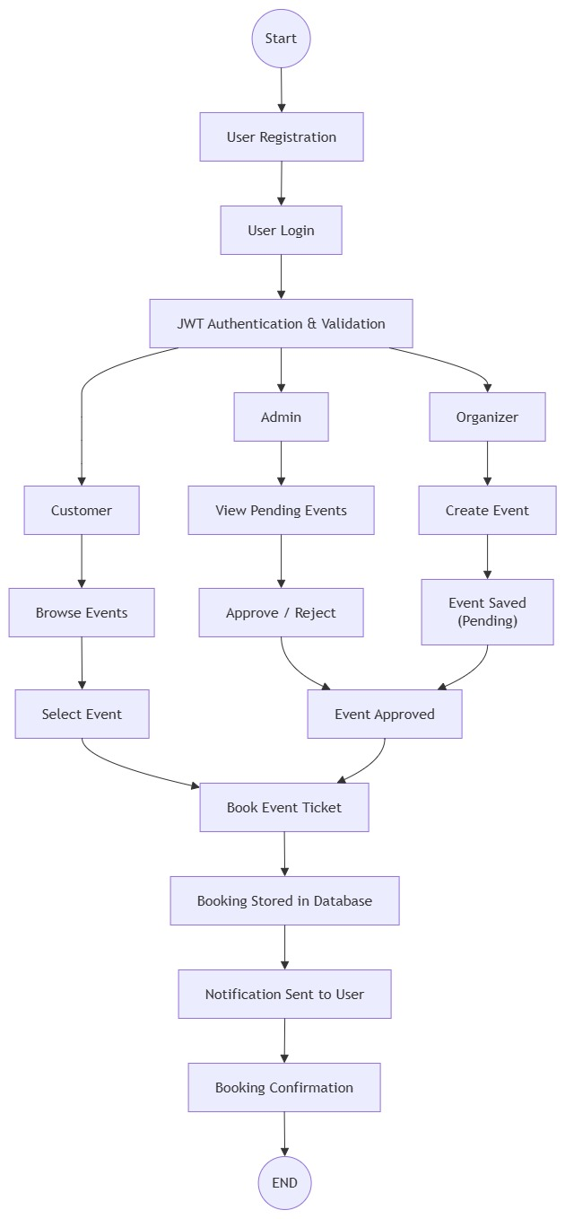

7. Assumptions
- All users have access to a modern web browser and a stable internet connection.
- A MongoDB instance (local or cloud-hosted) is available and reachable by the backend server at all times.
- Each event is associated with exactly one Organizer and one fixed ticket price; tiered or dynamic pricing is not required for the current scope.
- Payment collection is simulated for demonstration purposes; no live payment gateway is integrated in the current version.
- Administrator accounts are provisioned directly in the system and are not available through open self-registration.
- A single booking transaction is limited to a maximum of ten tickets, as enforced by the booking schema.
- Event approval decisions made by an Administrator are final unless the Organizer resubmits a revised event.

8. Implementation
This section documents the practical implementation of EventHub, covering data handling, processing steps, and key screens of the deployed application.

8.1 Data Collection and Processing
User-provided data (registration details, event details, booking requests) is collected through React forms on the client and sent as JSON payloads to the Express REST API. Each request passes through authentication middleware (protect), which verifies the JWT, and role-authorization middleware (authorize), which restricts access based on the user's role, before reaching the relevant controller. Controllers validate and process the data using express-validator and Mongoose schema rules, then persist or retrieve documents from the appropriate MongoDB collection.

8.2 User Registration and Authentication
New users register through a dedicated form that lets them choose between a Customer account ("Book tickets & attend") and an Organizer account ("Create & host events"), along with their name, email, password. 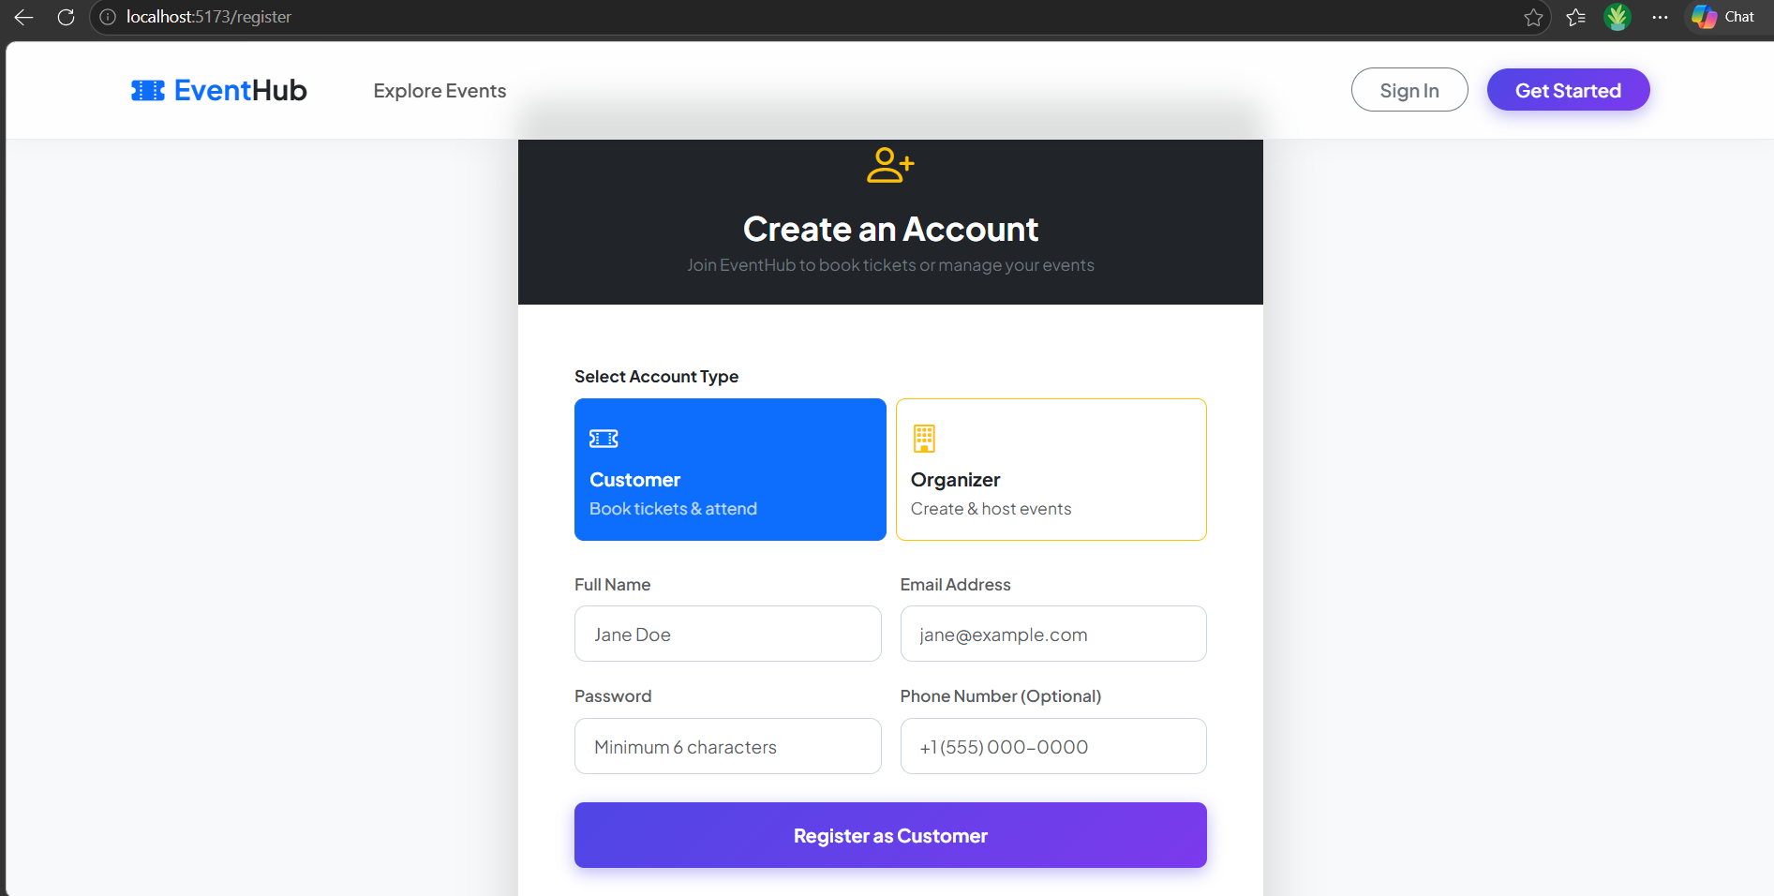

Figure 1: Account registration page with role selection (Customer / Organizer).
Returning users authenticate through the sign-in page. On successful login, the server returns a signed JWT that the client stores for use in subsequent authenticated requests. A one-click demo access option is also provided for quickly previewing each role.

8.3 Public Event Discovery
Unauthenticated visitors can browse all approved, upcoming events on the Explore Events page, viewing key details such as category, date and time, location, price, and live seat availability before choosing to sign in or register to complete a booking.
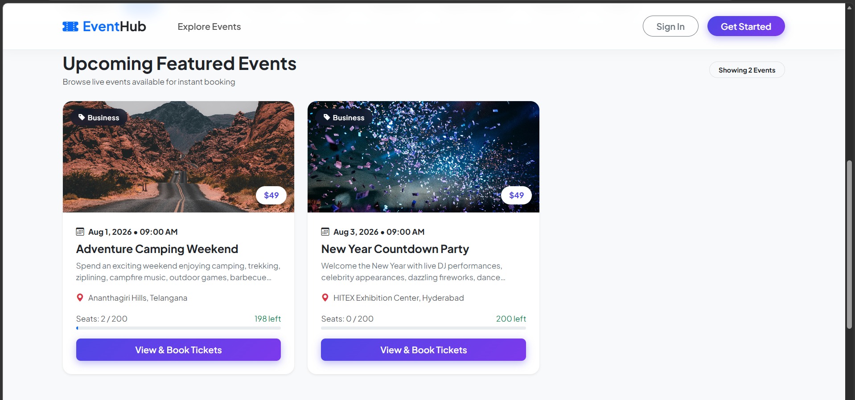
Figure 2: Public "Explore Events" listing showing approved events with pricing and seat availability.

8.4 Customer / Home Experience
Once logged in, users land on a home page featuring a search bar, category filters, and a curated banner of world-class events, giving quick access to the platform's core booking functionality regardless of role.

8.5 Organizer Dashboard
Organizers manage their events through a dedicated dashboard summarizing hosted events, total seats sold, and gross revenue, along with an events control panel for editing, deleting, or viewing attendees for each event and its live approval status.
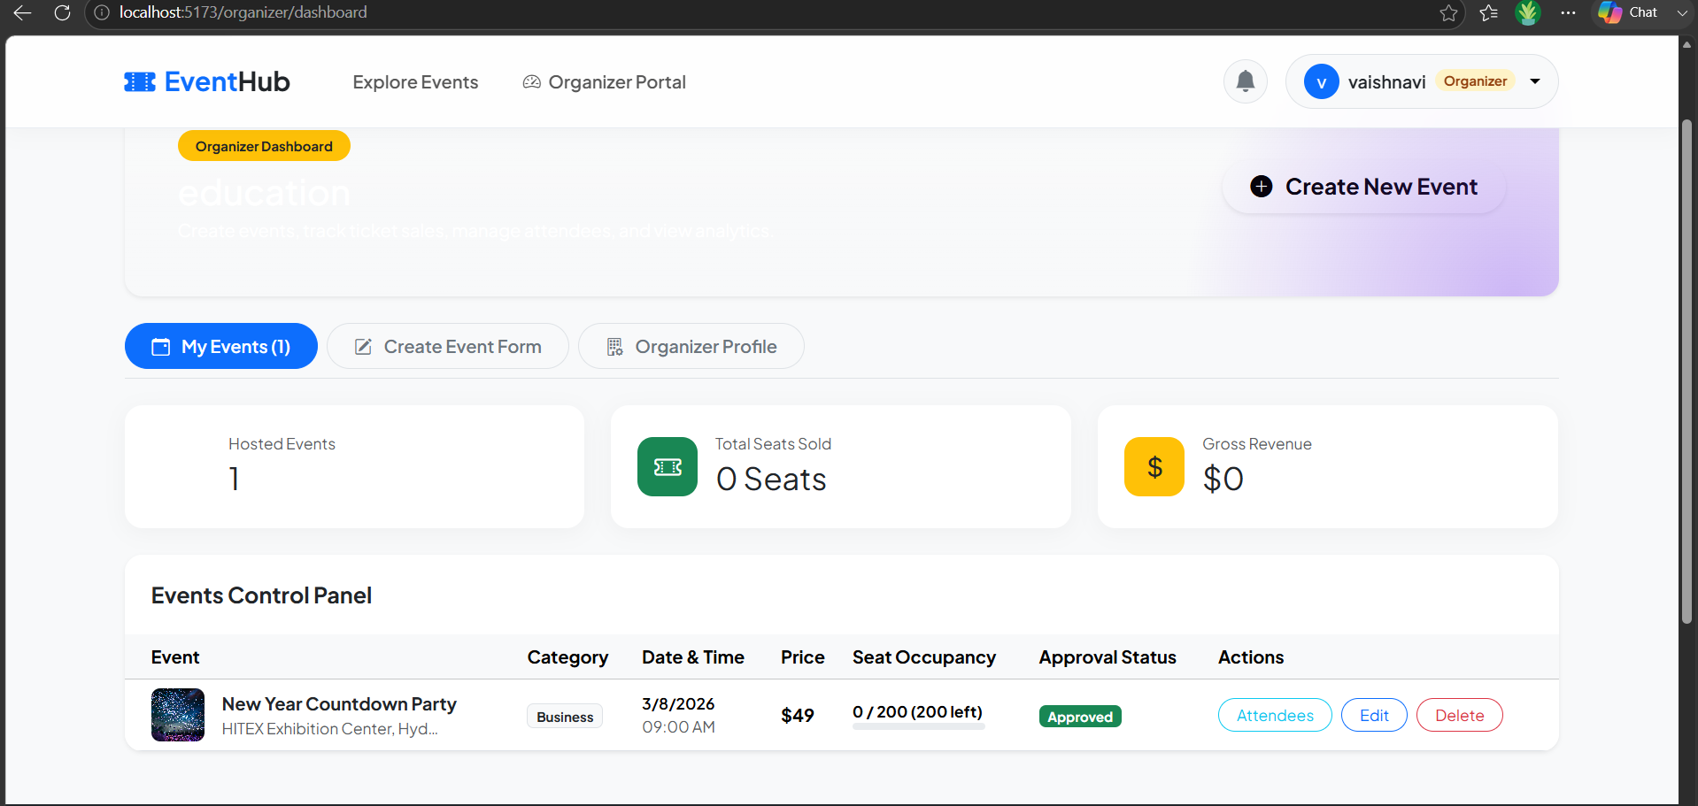
Figure 3: Organizer Dashboard showing hosted events, seat occupancy, pricing, and approval status.

8.6 Admin Dashboard — Analytics
Administrators are presented with a System Command Center that summarizes platform-wide metrics — total users, active events, confirmed bookings, and gross revenue — alongside visual analytics for monthly revenue growth and event category distribution.
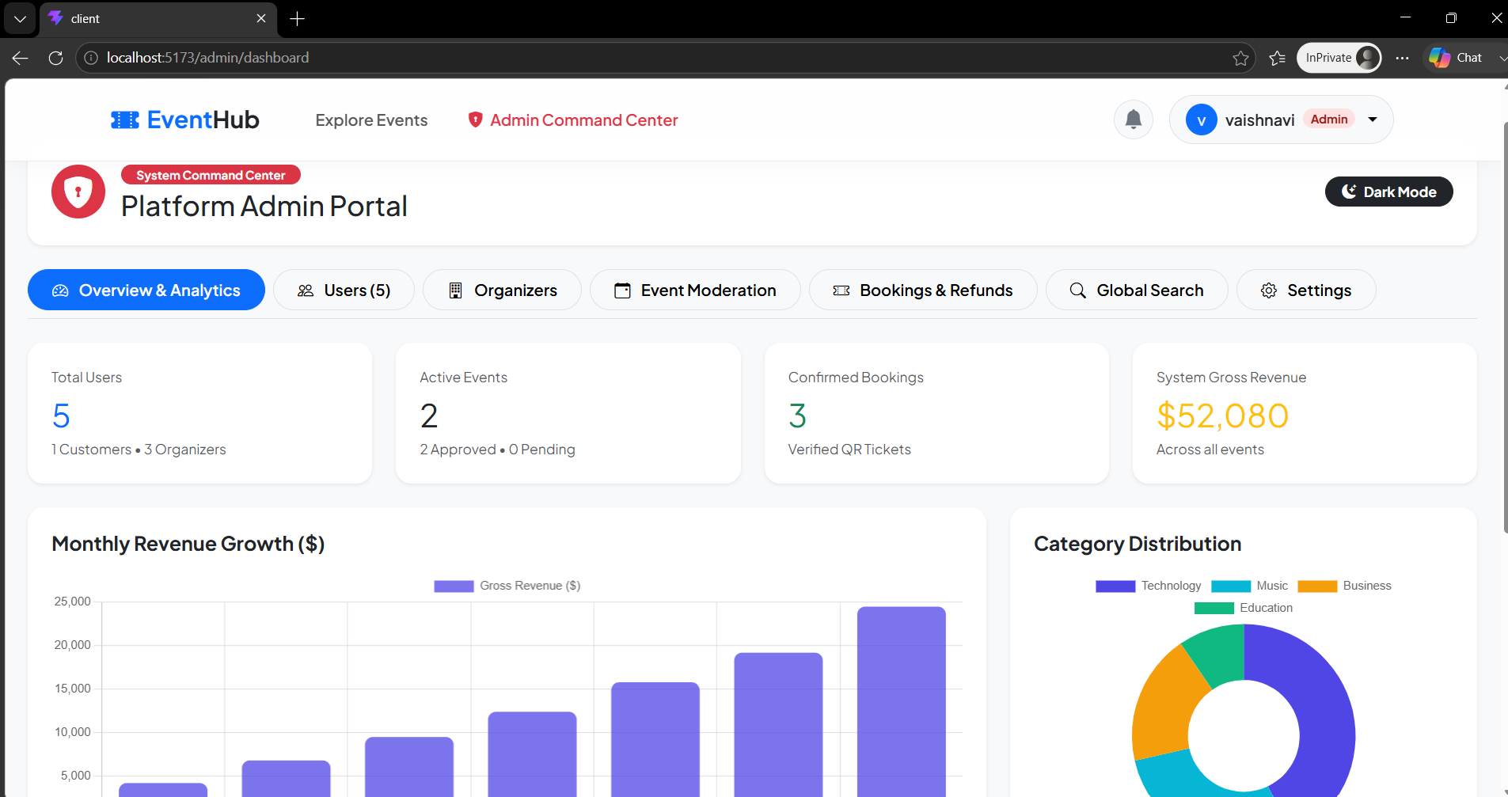
Figure 4: Admin "Overview & Analytics" panel with platform metrics, revenue growth chart, and category distribution chart.

8.7 Admin Dashboard — Bookings and Refunds
The Bookings & Refunds panel gives administrators a consolidated, system-wide view of every booking record — including the customer, event, amount, confirmation status, and refund status — with the ability to simulate a refund for any booking directly from the console.

9. Solution Design

9.1 System Architecture
EventHub follows a three-tier client–server architecture. The React single-page application (client tier) communicates over HTTPS with a stateless Express REST API (application tier), which in turn persists and retrieves data from a MongoDB database (data tier) through the Mongoose ODM. Authentication is stateless: the server issues a signed JWT at login, which the client attaches as a Bearer token on every subsequent request; the server verifies this token on each protected route rather than maintaining server-side sessions.
On the backend, incoming requests flow through a layered pipeline: Express routes → authentication middleware (protect) → role-authorization middleware (authorize) → controller logic → Mongoose models. This separation keeps cross-cutting concerns such as authentication and access control isolated from business logic, making the API easier to extend and maintain.
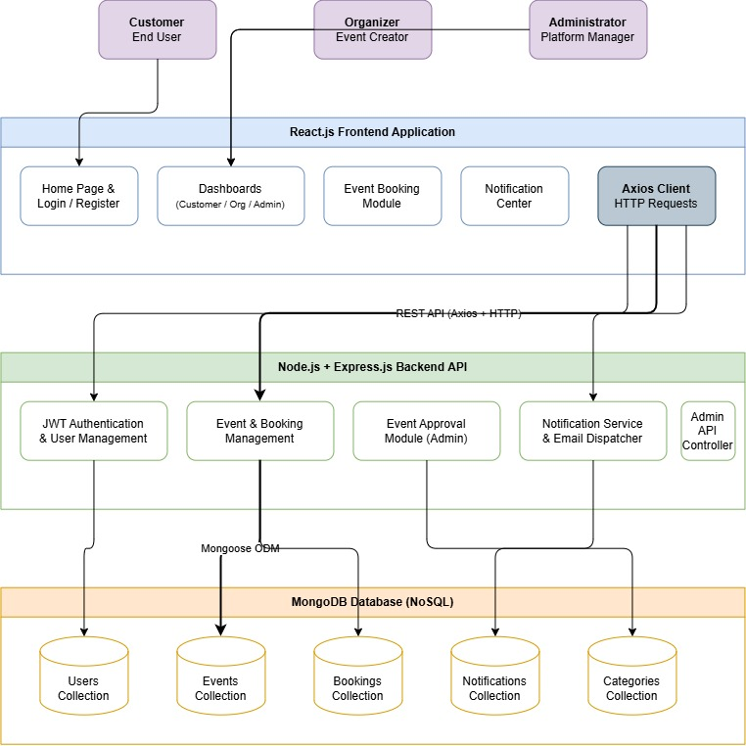

9.2 Database Design
The application uses five core MongoDB collections, modelled with Mongoose schemas:
Collection | Purpose | Key Fields
Users | Stores account details for Customers, Organizers, and Admins | name, email, password (hashed), role, phone, organization, isActive
Events | Stores event listings created by Organizers | title, description, category, date, time, location, price, capacity, bookedSeats, approvalStatus, organizer
Bookings | Stores ticket bookings made by Customers | customer, event, quantity, unitPrice, totalPrice, status, bookingReference, qrCodeUrl
Categories | Stores configurable event categories managed by Admins | name, description, icon
Notifications | Stores in-app alerts for registrations, approvals, and bookings | recipient, sender, type, title, message, isRead
Each Booking document automatically generates a unique bookingReference (e.g., EVT-5HPRHJE) and a corresponding QR code URL through a Mongoose pre-save hook, ensuring every confirmed ticket is independently verifiable. The Event schema exposes a virtual availableSeats field, computed as capacity minus bookedSeats, so seat availability is always derived consistently rather than duplicated in the database.
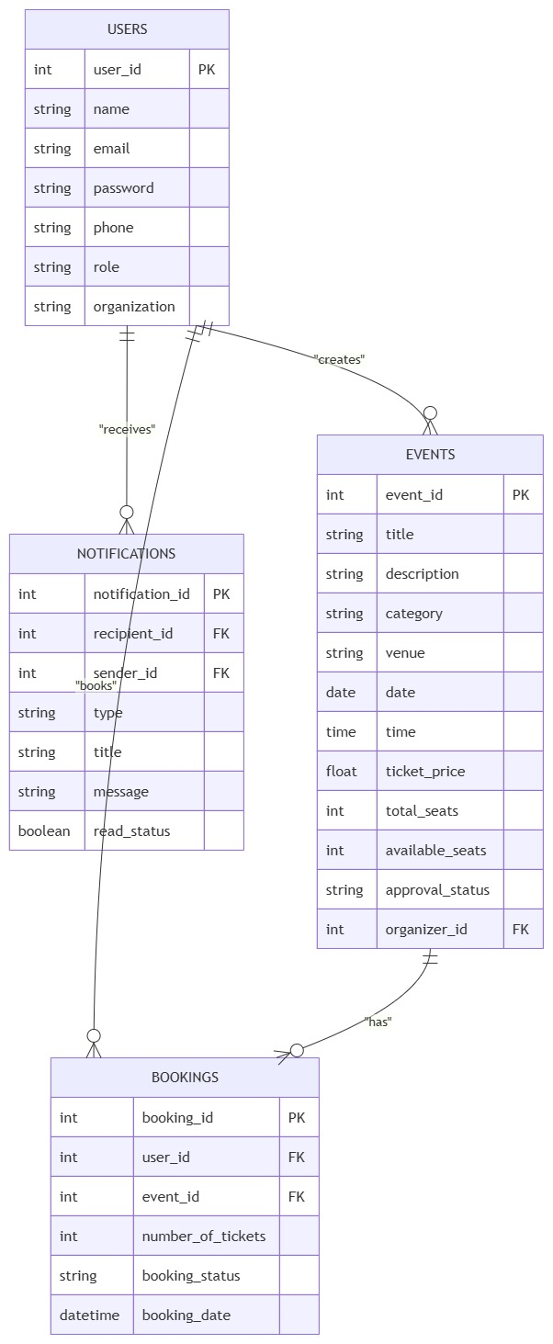

User Interface Wireframes

Wireframes are low-fidelity visual representations of the Online Event Booking and Management System that illustrate the layout and structure of each application screen before development. They provide a clear overview of the user interface, navigation flow, and placement of key components such as forms, dashboards, event listings, booking modules, and notifications. These wireframes helped in planning the application's functionality, ensuring a user-friendly design, and identifying interface requirements before implementation. They served as a blueprint for developing a consistent, responsive, and intuitive web application.
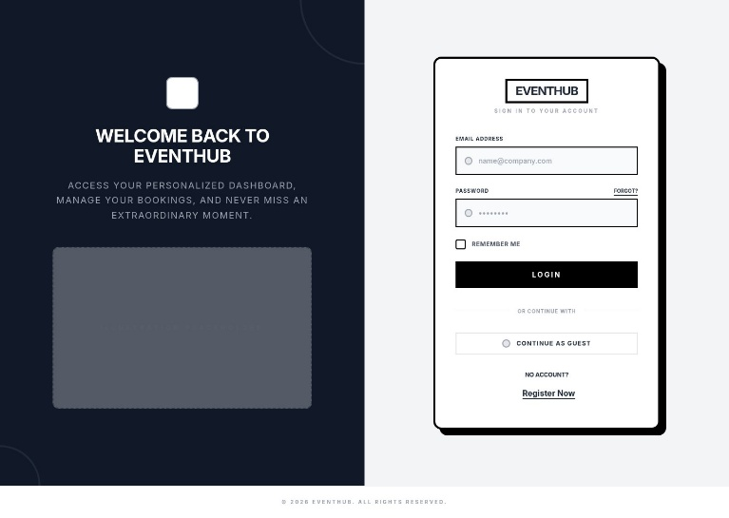 | 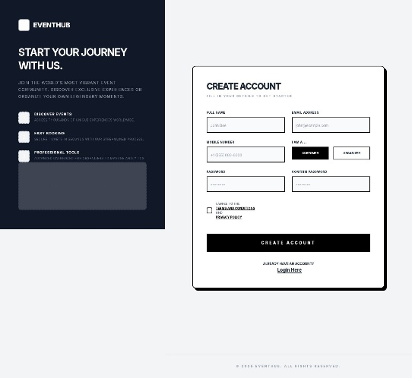
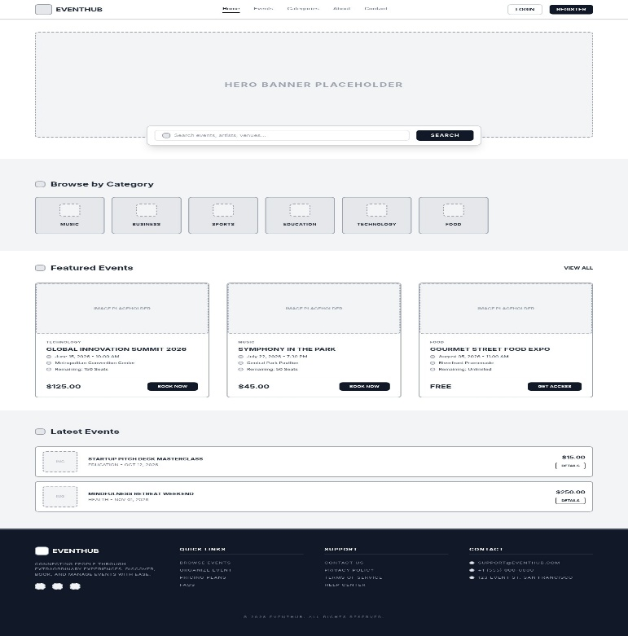 | 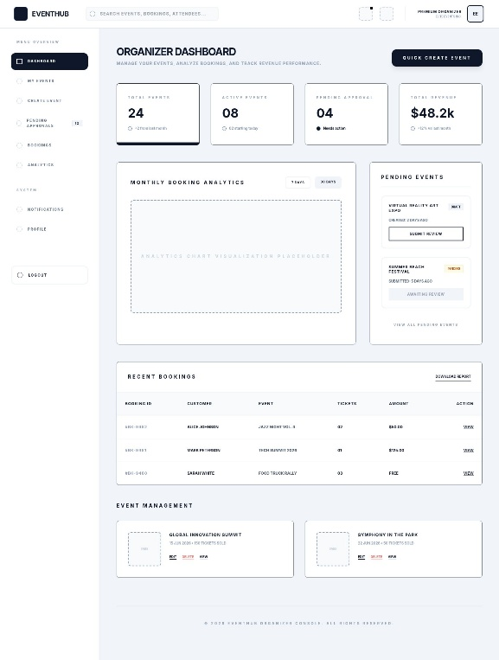
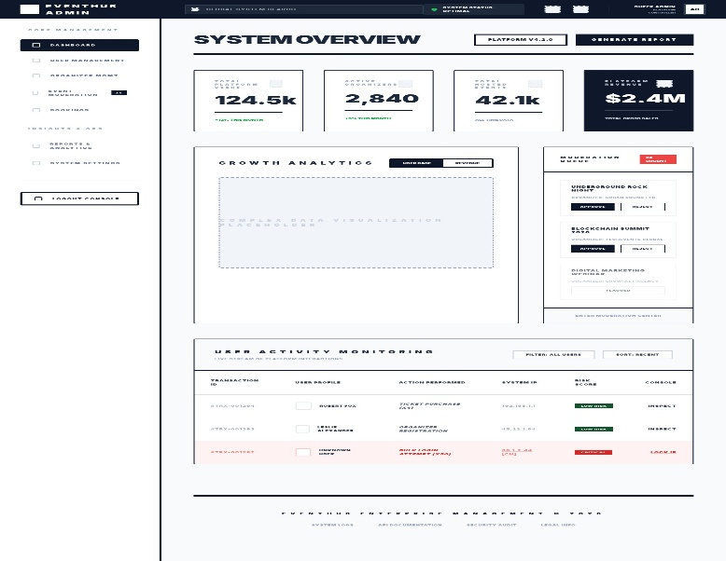 | 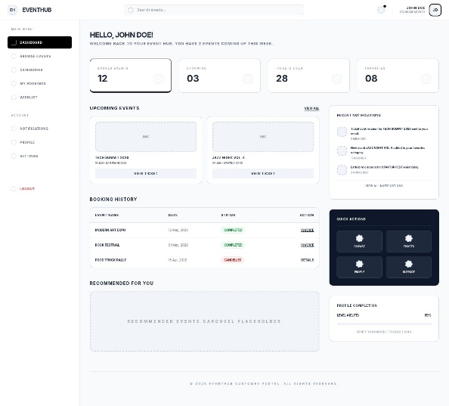

9.3 Role-Based Access Control
Three roles — Customer, Organizer, and Admin — are enforced through a combination of the protect middleware (which verifies the JWT and attaches the authenticated user to the request) and the authorize(...roles) middleware (which restricts a route to one or more roles). For example, event creation is limited to Organizer and Admin roles, while booking creation is limited to Customer and Admin roles, and the entire /admin route namespace is restricted to the Admin role.

9.4 REST API Design
The backend exposes a versioned REST API under /api/v1, organized by resource:
Method | Endpoint | Description | Access
POST | /auth/register | Register a new Customer or Organizer account | Public
POST | /auth/login | Authenticate a user and issue a JWT | Public
GET | /auth/me | Retrieve the logged-in user's profile | Authenticated
GET | /events | List approved events with search/pagination | Public
POST | /events | Create a new event (Pending approval) | Organizer / Admin
PUT | /events/:id | Update an existing event | Organizer (Owner) / Admin
DELETE | /events/:id | Cancel or delete an event | Organizer (Owner) / Admin
POST | /bookings | Book tickets for an event | Customer
GET | /bookings/my-bookings | Retrieve the logged-in customer's bookings | Customer
PUT | /bookings/:id/cancel | Cancel a booking | Customer (Owner) / Admin
GET | /admin/stats | Retrieve platform-wide summary statistics | Admin
GET | /admin/analytics | Retrieve revenue and category analytics data | Admin
PUT | /admin/events/:id/approval | Approve or reject a pending event | Admin
GET | /admin/bookings | Retrieve all system-wide bookings | Admin
GET | /notifications | Retrieve the logged-in user's notifications | Authenticated

10. Challenges and Opportunities

10.1 Challenges Faced
- Designing and correctly enforcing JWT-based authentication together with fine-grained, role-based route authorization across a large number of endpoints.
- Ensuring the event approval workflow (Pending → Approved/Rejected) integrated cleanly with both the Organizer and Admin dashboards without exposing unapproved events publicly.
- Keeping bookedSeats and derived availableSeats consistent as multiple customers book tickets for the same event.
- Generating a unique, human-readable booking reference and an accompanying QR code automatically and reliably at the point of booking.
- Structuring the Mongoose schemas (Users, Events, Bookings, Categories, Notifications) to support all three roles cleanly while avoiding data duplication.
- Building responsive, data-driven Admin analytics views (revenue growth and category distribution charts) using Chart.js integrated with live API data.
- Coordinating state and authenticated API calls across multiple React pages and dashboards through a shared authentication context.

10.2 Opportunities
- Integrating a real payment gateway would allow the platform to move from simulated transactions to genuine commerce.
- Adding automated backend and frontend test suites would improve long-term reliability as the codebase grows.
- Containerizing the application would simplify deployment to a cloud environment and enable horizontal scaling.

11. Reflections on the Project
Building EventHub provided practical, end-to-end experience with the MERN stack, from designing normalized MongoDB schemas and building a secure, role-aware REST API, to implementing a responsive React front end with protected routes and role-specific dashboards. Implementing JWT authentication and middleware-based authorization reinforced the importance of separating security concerns from business logic. Designing the event-approval workflow and the automatic booking-reference/QR-code generation also highlighted how small design decisions in the data model (such as Mongoose pre-save hooks and virtual fields) can meaningfully simplify application logic elsewhere in the system. Overall, the project deepened both technical proficiency in full-stack JavaScript development and an appreciation for structured, iterative software development.

12. Recommendations
- Introduce automated testing (e.g., Jest and Supertest for the backend, React Testing Library for the frontend) to safeguard against regressions.
- Integrate a real payment gateway (e.g., Stripe or Razorpay) to support genuine end-to-end transactions.
- Add additional security hardening such as HTTP security headers (Helmet), rate limiting, and refresh-token rotation.
- Move analytics aggregation to scheduled or cached queries to improve dashboard performance as data volume grows.
- Adopt a CI/CD pipeline for automated linting, testing, and deployment on every commit.

13. Outcome / Conclusion
EventHub successfully delivers a secure, full-stack, role-based online event booking and management platform that meets its stated objectives. The system enables Organizers to publish events through an administrator-moderated approval workflow, allows Customers to discover and book events with verifiable, QR-coded tickets, and equips Administrators with a comprehensive command center for user management, event moderation, booking oversight, and platform analytics. The completed application demonstrates practical, working implementation of modern full-stack web development concepts — including JWT-based authentication, role-based access control, RESTful API design, and MongoDB schema modelling — and provides a solid foundation for future enhancement.

14. Enhancement Scope
- Integration of a live payment gateway for real ticket transactions.
- Email and SMS notifications alongside the existing in-app notification system.
- A dedicated native mobile application for Android and iOS.
- AI-driven event recommendations based on user interests and booking history.
- Cloud deployment with CI/CD automation for continuous delivery.
- Advanced analytics such as attendee demographics and predictive demand forecasting.
- Multi-language and multi-currency support for broader accessibility.

15. Link to Code and Executable File
https://github.com/kalalvaishanavi-ops/online-event-system

16. Research Questions and Responses

Q1. Why was the MERN stack chosen over other technology combinations?
The MERN stack (MongoDB, Express.js, React.js, Node.js) allows JavaScript to be used consistently across both the client and server, reducing context-switching during development. Its component-based frontend (React) and flexible, document-oriented database (MongoDB) were well suited to an application with varied, evolving entities such as events, bookings, and notifications.

Q2. Why was JWT chosen for authentication instead of traditional session-based authentication?
JWT enables stateless authentication, meaning the server does not need to store session data in memory or a session store. This simplifies horizontal scaling and keeps the API lightweight, since each request carries its own verifiable proof of identity and role.

Q3. Why is MongoDB used instead of a relational database?
MongoDB's flexible, document-based schema was well suited to entities like Events and Bookings, whose structure could evolve over time (for example, adding new fields for featured events or QR codes) without requiring rigid schema migrations, while Mongoose still enforces validation and structure at the application layer.

Q4. How is data consistency maintained when multiple customers book the same event concurrently?
Each booking request is processed through the booking controller, which recalculates available seats from the Event document's capacity and bookedSeats fields at the time of booking before confirming the transaction, reducing the likelihood of overbooking under normal load.

17. References
- React Documentation — https://react.dev
- Vite Documentation — https://vitejs.dev
- Express.js Documentation — https://expressjs.com
- MongoDB Documentation — https://www.mongodb.com/docs
- Mongoose Documentation — https://mongoosejs.com/docs
- JWT Introduction — https://jwt.io/introduction
- Bootstrap Documentation — https://getbootstrap.com/docs
- MDN Web Docs — https://developer.mozilla.org

